

School Of Engineering And Technology

Algorithm And Design Analysis

Submitted By ->
Name : MANYA YADAV
Roll Number : 2401420012
Course :- B.Tech CSE (DS)
Semester : - IV
Department :- SOET

Submitted To :- DR. AARTI SANGWAN
Submission Date :- 2-APRIL-2026
Course Code :- ENCS256
1. Graph Representation:-
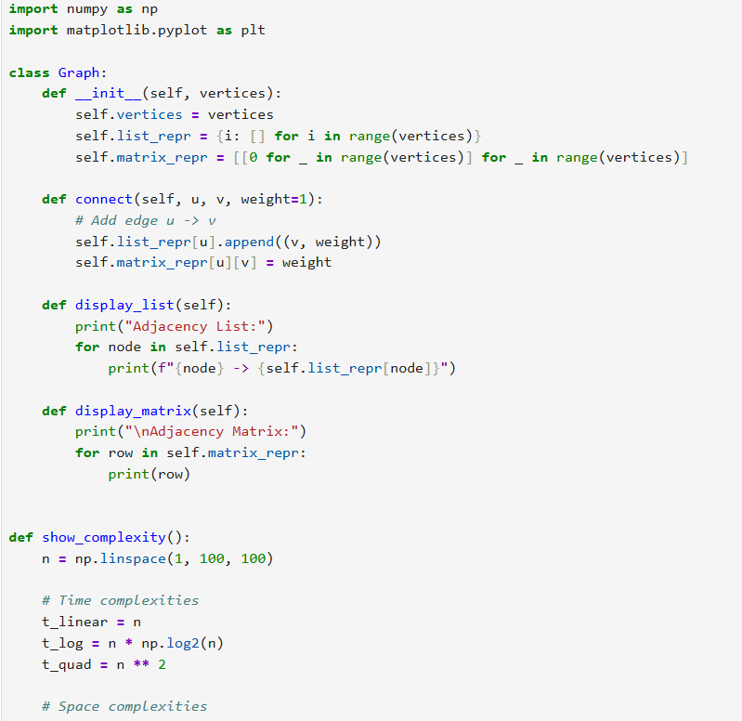
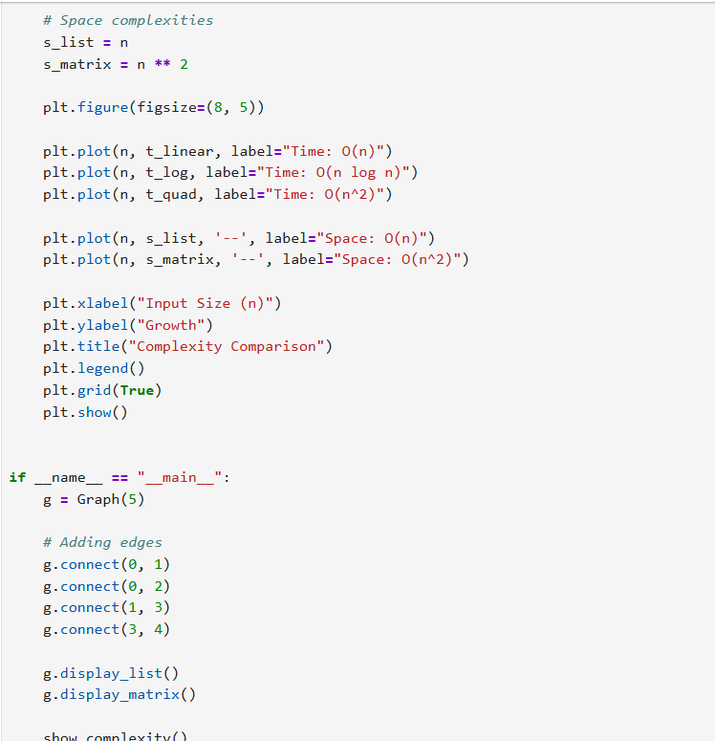

OUTPUT:-
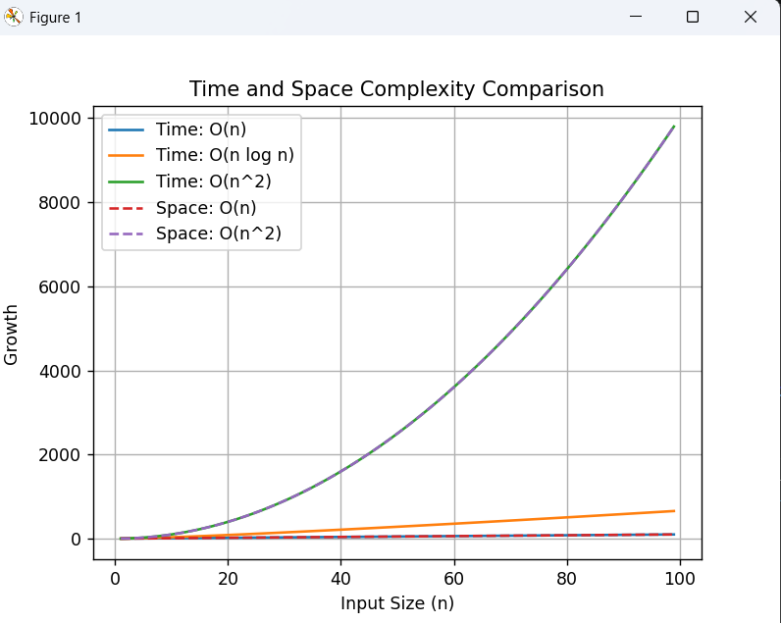

2. Depth First Search (DFS):-
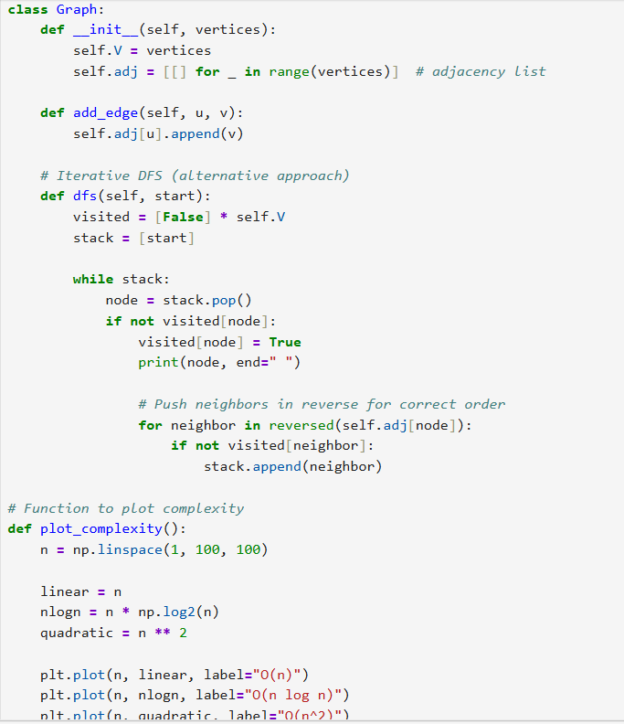
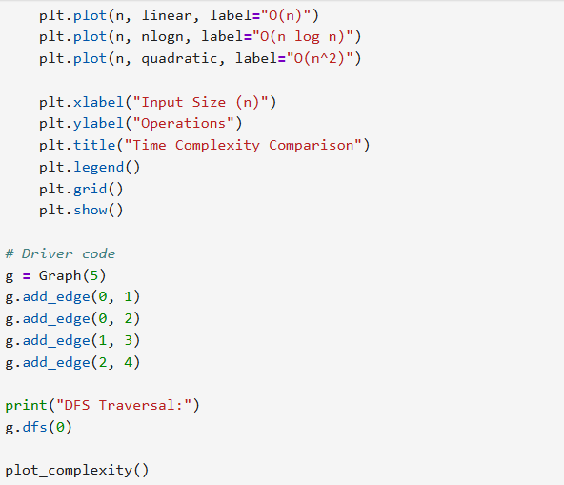

OUTPUT:-
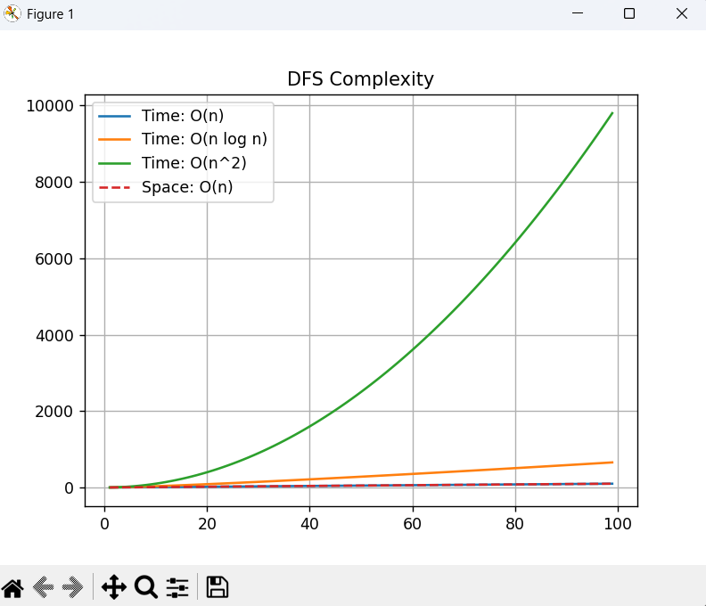

3. Breadth First Search (BFS):-
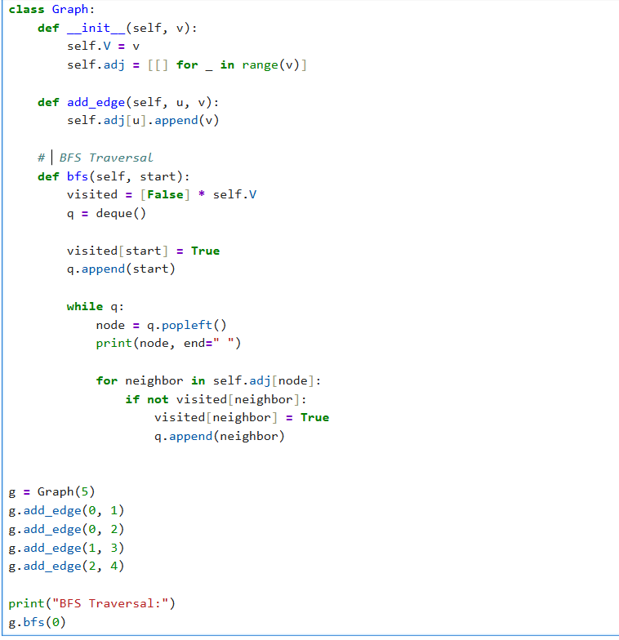
OUTPUT:- 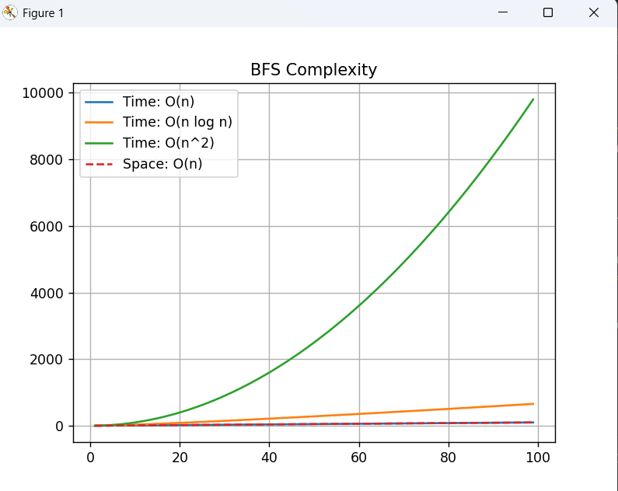
4. Topological sort :-
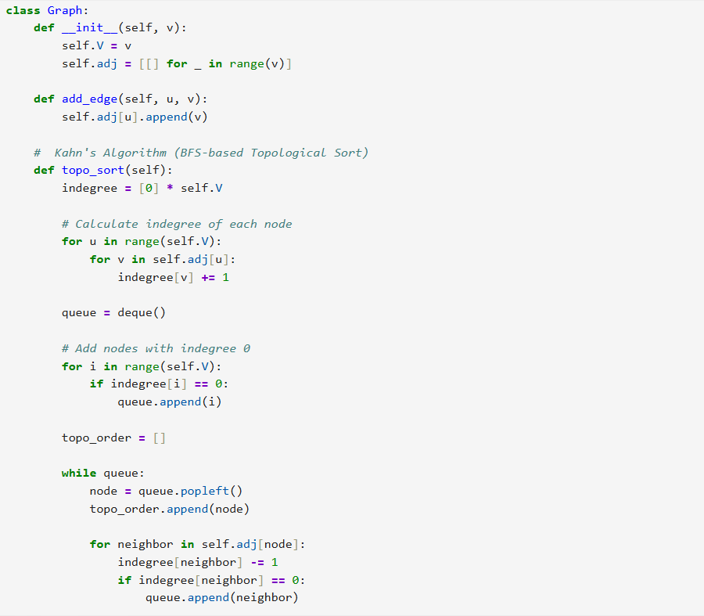
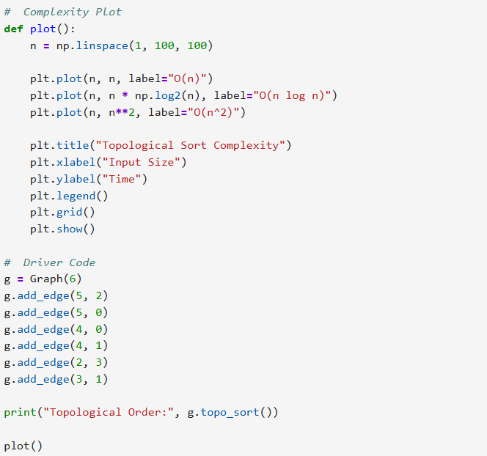

OUTPUT:-
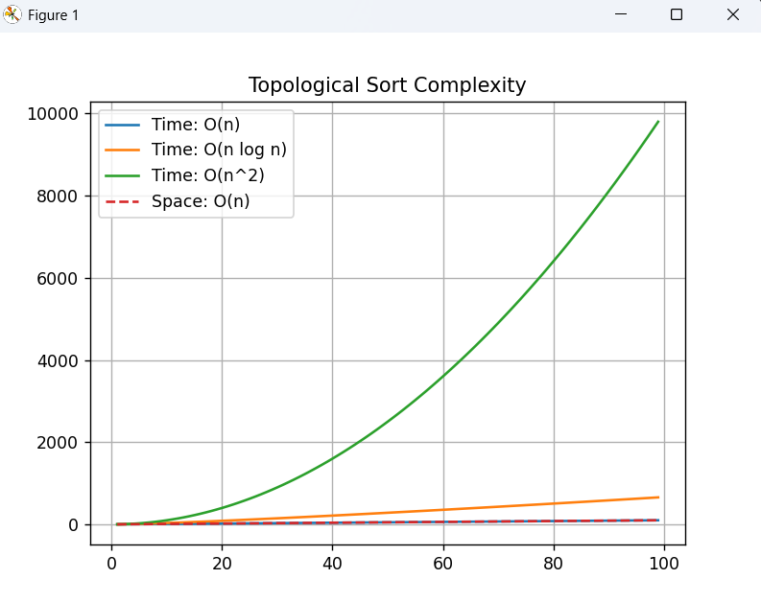

5. Topological Sort:-
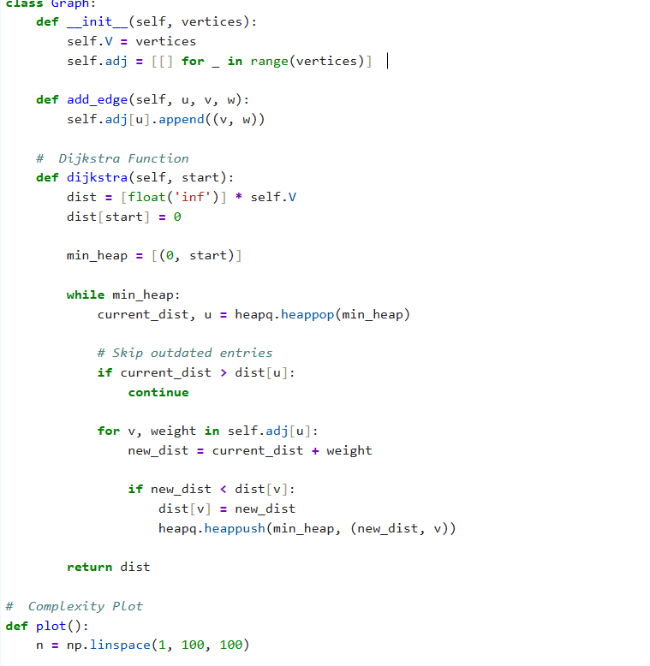
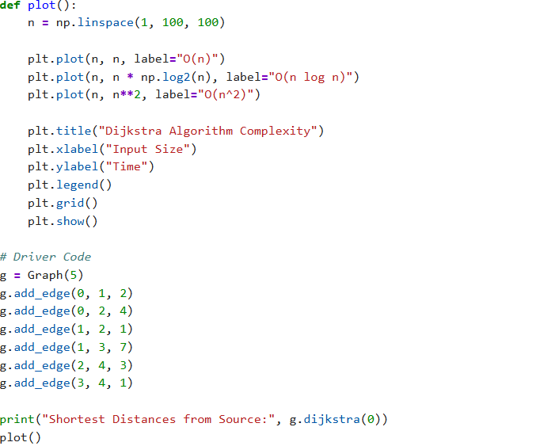

OUTPUT:-
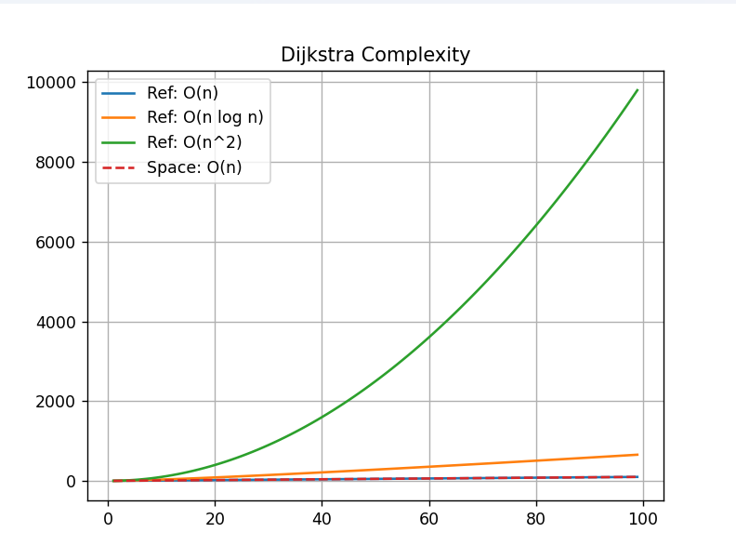
6. Bellman-Ford Algorithm:-
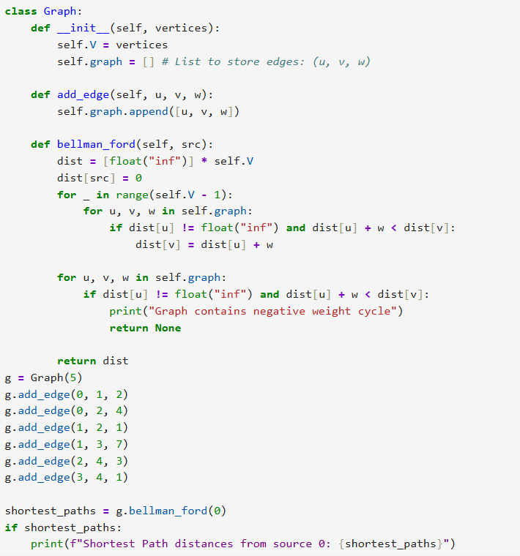

OUTPUT:-
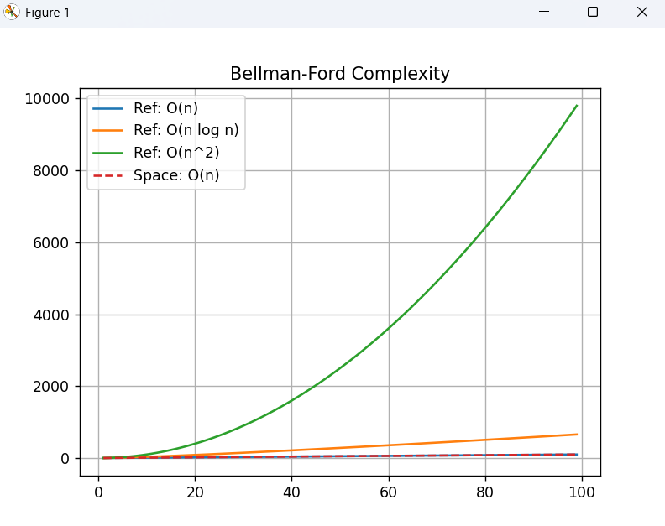
Github Link:- https://github.com/okayyymy15/MANYA_YADAV_ADA_ASSIGNMENTS

